An API Gateway is like a front door or a traffic controller for your apps and services. Imagine you have a bunch of different tools or services (like checking the weather, processing payments, or fetching data), and you want to make them easy to use. The API Gateway sits in the middle and handles all the requests coming in from users or apps.

Here’s what it does:
Routes Requests: It directs incoming requests to the right service. For example, if someone asks for weather info, it sends that request to the weather service.
Manages Security: It can check if the user is allowed to access the service (like a bouncer at a club).
Simplifies Things: Instead of users needing to know how to talk to each service, they just talk to the API Gateway, and it handles the rest.
Optimizes Performance: It can cache responses (store them temporarily) to make things faster for repeated requests.
Step 1: Open Amazon API Gateway
Log in to the AWS Management Console.
In the search bar at the top, type "API Gateway" and select it from the results.
Step 2: Click “Create API”
On the API Gateway dashboard, click the "Create API" button.
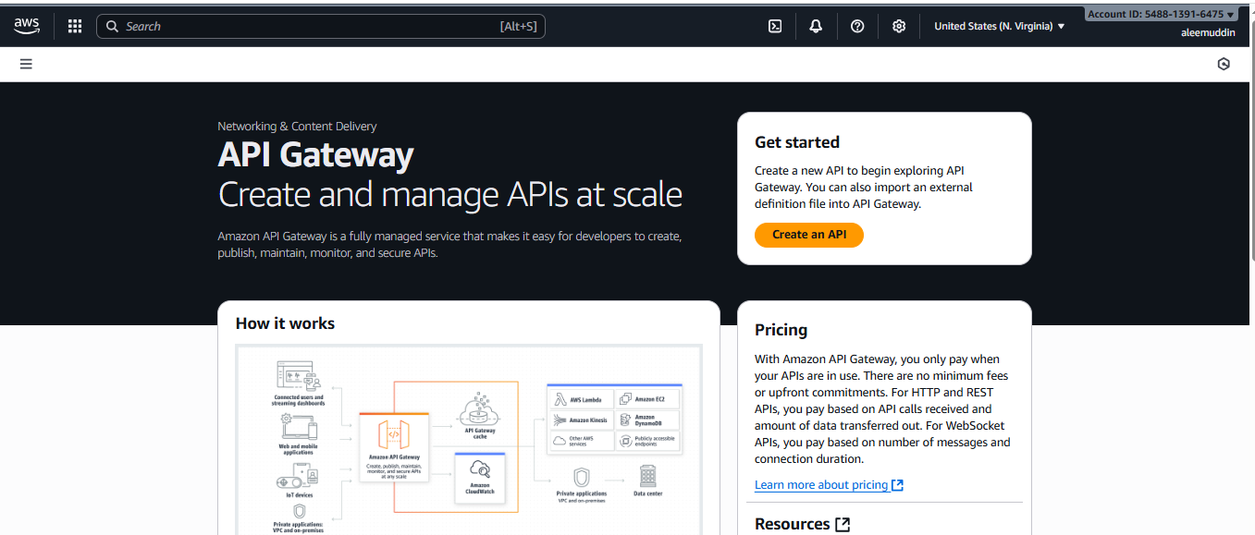
Step 3: Choose API Type
Select the type of API you want to create:
HTTP API: Simpler and low-cost, ideal for basic use cases.
REST API: More feature-rich, supports usage plans, API keys, and more.
WebSocket API: For real-time, bidirectional communication.
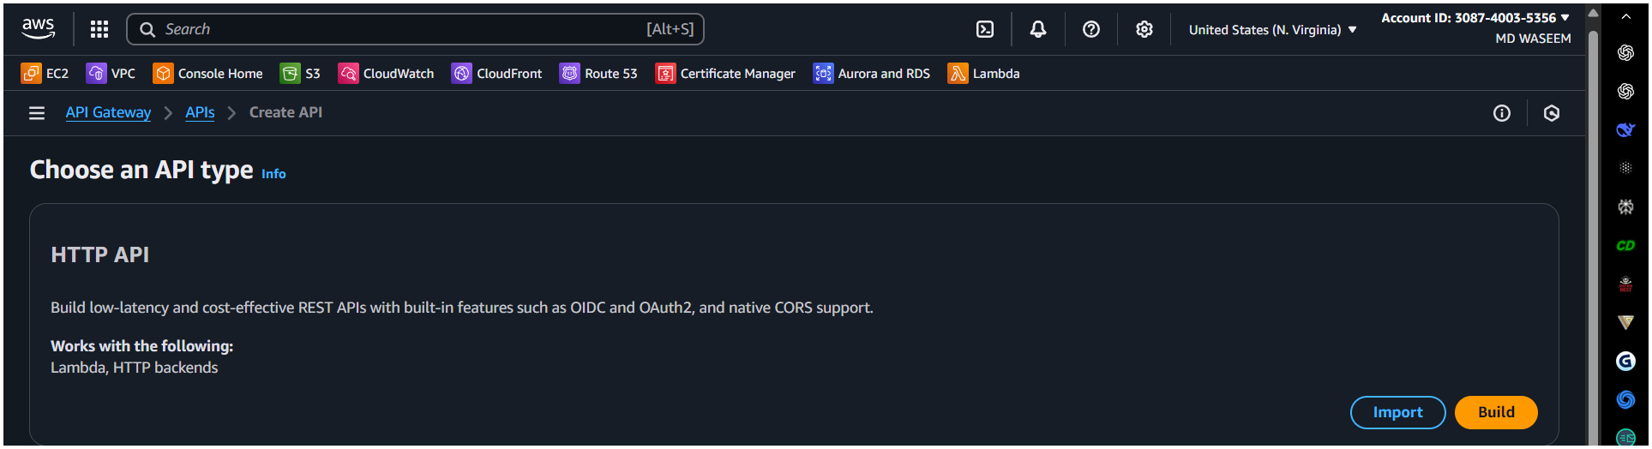

Step 4: Configure API Details
API Name: Enter a descriptive name for your API (e.g., MyTestAPI).
Description (Optional): Add a brief description of your API.
Endpoint Type (for REST API only):
Regional: Default option for APIs accessed within a specific AWS region.
Edge-optimized: Best for global clients, uses CloudFront for faster delivery.
Private: Accessible only within your VPC.

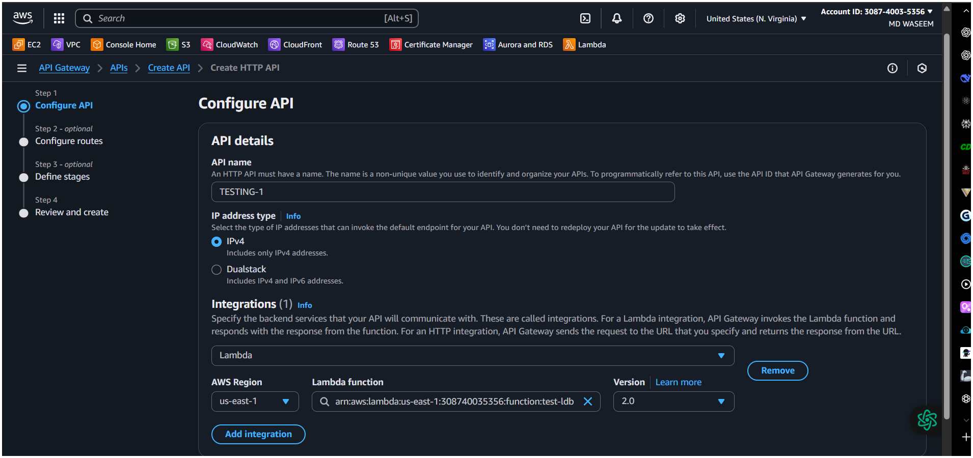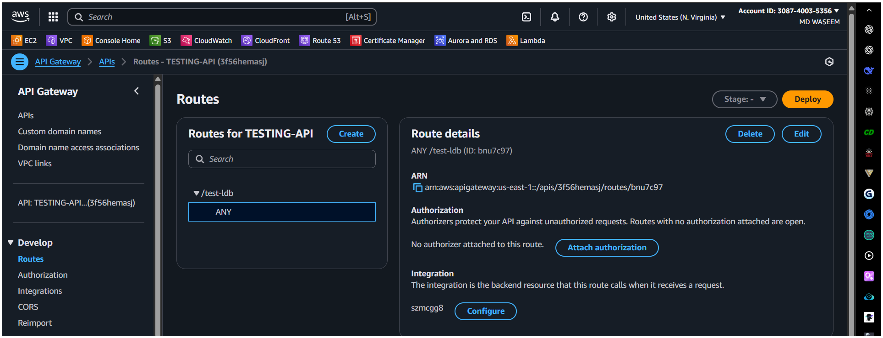
Step 5: Create Routes or Resources
For HTTP APIs:
Define routes (e.g., /users, /orders).
Assign HTTP methods (GET, POST, PUT, DELETE, etc.) to each route.
For REST APIs:
Define resources (e.g., /users, /orders).
Add methods (GET, POST, etc.) to each resource.

Step 6: Set Integration Target
Link your API to a backend service:
AWS Lambda function: Execute serverless code.
HTTP endpoint: Connect to an external HTTP service.
AWS service: Integrate with services like SQS, SNS, or DynamoDB.
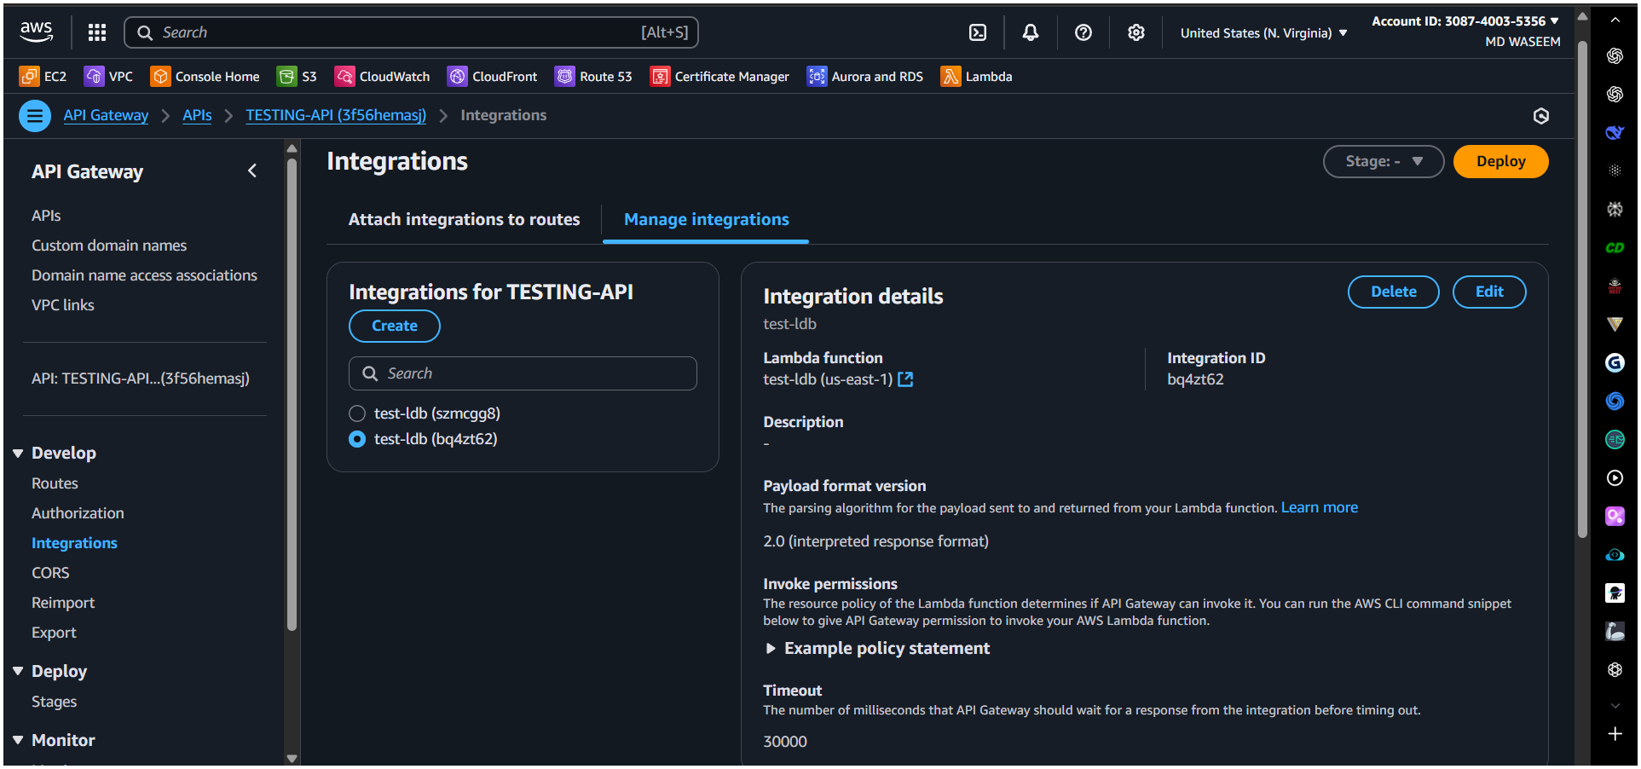
Step 7: Configure Authorization (Optional)
Protect your API by setting up authorization:
IAM roles: Use AWS Identity and Access Management for access control.
Cognito user pools: Authenticate users via Amazon Cognito.
Lambda authorizers: Use a custom Lambda function for authorization logic.
Step 8: Deploy the API
Create a stage (e.g., dev, test, prod) to deploy your API.
Click "Deploy" to make your API live.
AWS will generate a public invoke URL for your API (e.g., https://api-id.execute-api.region.amazonaws.com/stage).
Step 9: Test the API
Use tools like Postman, a web browser, or the AWS CLI to send HTTP requests to your API’s endpoint URL.
Validate the responses to ensure your API is working as expected.
Additional Tips
Monitoring: Use Amazon CloudWatch to monitor API performance and logs.
Throttling: Set up throttling limits to control the rate of requests.
Caching: Enable caching for REST APIs to improve performance.
Let me know if you need further clarification or help with any specific step! 😊

